Hi, I’m Alex

I travel, write, take pictures, and create websites. I'm happiest when I get to combine all of these and share it with the world. If you're interested in working with me please reach out using my contact page

Project info and images

Low Clearance Map

Low Clearance Map started as a website in fall 2021 to try and fill a gap in the market. The current Low Clearance Map website is donation based and has a database of over 10,000 structures across the US and Canada. The goal with this project was to bring that same functionality to an app, making it easier and more convenient for drivers to utilize while on the road.

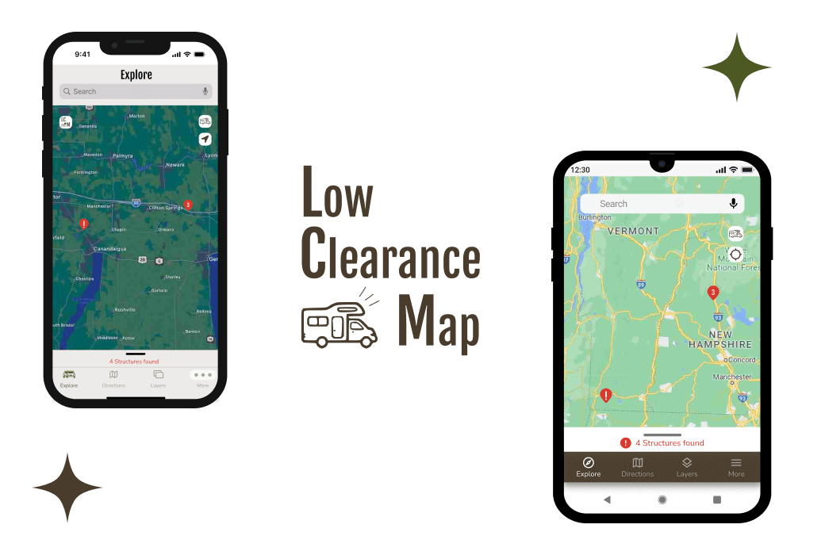

Dessert Hub

Dessert Hub focuses on creating a solution for users who dislike or struggle with the current selection of recipe sites that are available. This site focuses on creating user-centered design and solving problems that potential users brought up during interviews and design testing. My design reflects my user’s needs and helps them achieve their goals. 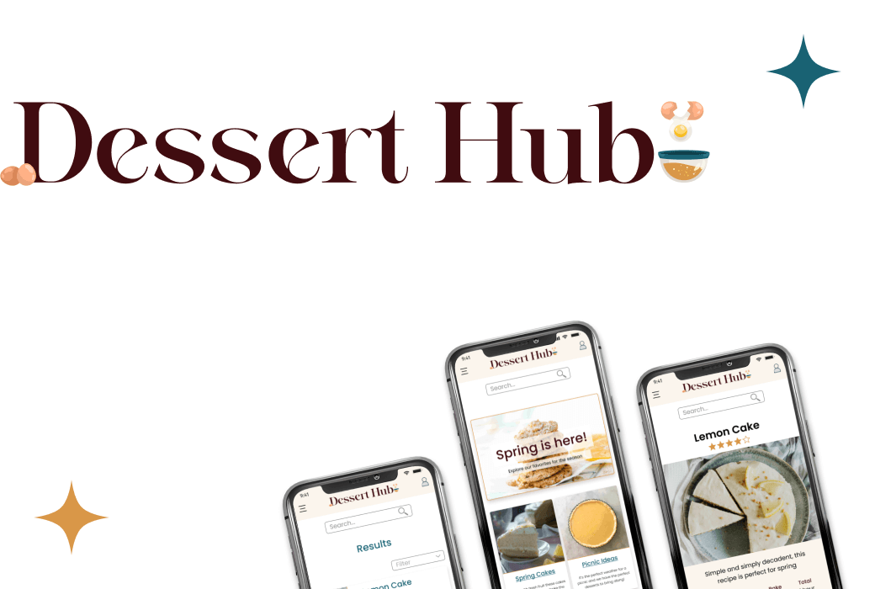

Recycled Reads

Recycled Reads helps users find that perfect book quickly and easily. All of the selection is second hand, so users also get to help the environment while helping their shelves. The ability to save and review books to get personalized recommendations keeps users coming back.

